December 25, 1914
Faith of Abraham; Mutual Linkage Exists Between Verses, Sections and Chapters of the Holy Quran
I bear witness that none deserves to be served besides Allah and I bear witness that Muhammad is the servant and messenger of Allah. —
After this, I seek the protection of Allah from the accursed devil.
In the name of Allah, the Beneficent, the Merciful.
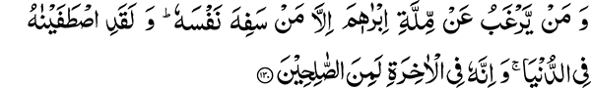
“And who forsakes the religion of Abraham but he who makes a fool of himself. And certainly We made him pure in this world and in the Hereafter he is surely among the righteous.” (2:130)
“When his Lord said to him, Submit, he said: I submit myself to the Lord of the worlds” (2:131)
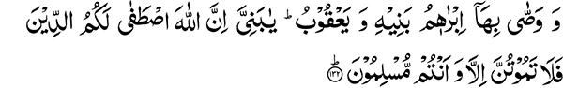
“And the same did Abraham enjoin on his sons, and (so did) Jacob: O my sons, surely Allah has chosen for you (this) religion, so die not unless you are submitting ones.” (2:132)
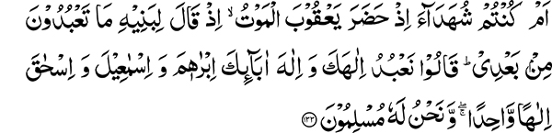
“Or were you witnesses when death visited Jacob, when he said to his sons: What will you serve after me? They said: We shall serve thy God and the God of thy fathers, Abraham and Ishmael and Isaac, one God only, and to Him do we submit.” (2:133)
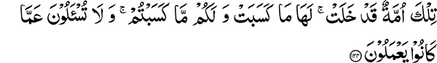
“Those are a people that have passed away; for them is what they earned and for you what you earn; and you will not be asked of what they did.” (2:134)
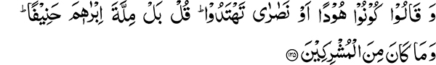
“And they say: Be Jews or Christians, you will be on the right course. Say: Nay, (we follow) the religion of Abraham, the upright one, and he was not one of the polytheists.” (2:135)
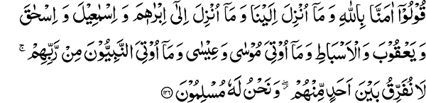
“Say: We believe in Allah and (in) that which has been revealed to us, and (in) that which was revealed to Abraham, and Ishmael and Isaac and Jacob and the tribes, and (in) that which was given to Moses and Jesus, and (in) that which was given to the prophets from their Lord, we do not make any distinction between any of them and to Him do we submit.” (2:136)
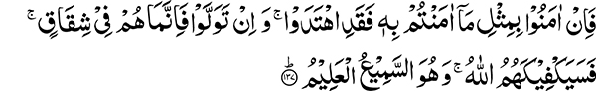
“So if they believe as you believe, they are indeed on the right course; and if they turn back, then they are only in opposition. But Allah will suffice thee against them; and He is the Hearing, the Knowing” (2:137)
“(We take) Allah’s colour, and who is better than Allah at colouring, and we are His worshippers.” (2:138)
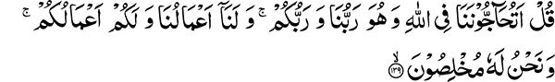
“Say: Do you dispute with us about Allah, and He is our Lord and your Lord, and for us are our deeds and for you your deeds; and we are sincere to Him?” (2:139)
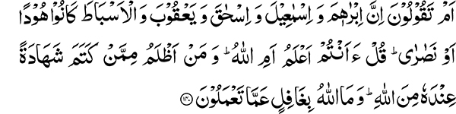
“Or do you say that Abraham and Ishmael and Isaac and Jacob and the tribes were Jews or Christians? Say: Do you know better or Allah? And who is more unjust than he who conceals a testimony that he has from Allah? And Allah is not heedless of what you do” (2:140)
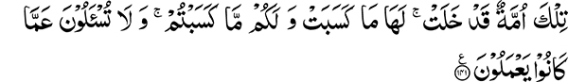
“Those are a people that have passed away; and for them is what they earned and for you what you earn; and you will not be asked of what they did.” (2:141)
This is the last section of the first part of the Holy Quran and section sixteen of the second chapter Al Baqarah. Since I have come to Lahore, I recited and commented on one section of the Holy Quran in each Friday sermon. Incidentally, this section is the subject of my sermon (khutba) today. A translator of the Holy Quran commented in a footnote to this section stating that the uniqueness of this section is that it discusses the same subject throughout. People’s unfamiliarity with the Holy Quran is indeed very surprising. They think there is no continuity within the rest of the Holy Quran. Remember however, as far as we have pondered this subject we have found a linkage between each verse, each section, and each chapter of the Holy Quran and that there is no room for changing their arrangement. This wonderful characteristic of the Holy Quran becomes evident to anyone who studies it carefully. Before this section, all of Al Baqarah contains discussions with the Jews. They were given all sorts of proofs in order to convince them to accept Islam and the Holy Prophet Muhammad. It is pointed out that their denial of the Quranic revelation is because it came to a nation other than their own. They also questioned why their religious law is abrogated. The answer to this question is that the religion brought through the revelation of the Holy Quran is the same that was revealed to the Jewish patriarch, Abraham. Whether you are a Jew or a Christian, you are all from the progeny of Abraham. How can you then deny this religion? The Holy Quran states: “And who forsakes the religion of Abraham but he who makes a fool of himself.” This foolishness and denial affects your own person. By denying him you deprive yourself of his righteous teachings. Regarding Abraham, Allah the most High says: “And certainly We made him pure in this world and in the Hereafter he is surely among the righteous.”
The Faith of Abraham and Those Following the Path of Excess or Deficiency
The status of Abraham amongst the nations of the world is such that the prayer for the Holy Prophet Muhammad recited by Muslims in their daily services asks Allah to give Muhammad those blessings of acceptance that He gave to Abraham. The question that arises is, what was the faith of Abraham? Regarding this, the Holy Quran informs us: “When his Lord said to him, Submit, he said: I submit myself to the Lord of the worlds.” And also: “Nay, (we follow) the religion of Abraham, the upright (hanif) one.” The word upright (hanif) has been used in the Holy Quran for Prophet Abraham, the Holy Prophet Muhammad and Muslims. What is meant by being upright? It refers to one who is straightforward in his dealings and not inclined to one side or the other by following the path of excess or deficiency.
“And they say: Be Jews or Christians, you will be on the right course. Say: Nay, (we follow) the religion of Abraham, the upright one…” (2:135)
The Holy Quran disagrees with their contention that one could be on the right course by becoming a Jew or a Christian. It tells them that they have followed the path of either excess or deficiency in their faith, unlike Abraham who was forthright and followed the right course. The Holy Quran also tells us, “Guide us on the right path, the path of those upon whom thou has bestowed favors not those upon whom wrath was brought down nor those who went astray” (1:5-7). The Jews were deficient in their faith because they rejected their prophets, including one of their great prophets, Jesus. “And they incurred Allah’s wrath. This was because they disbelieved in the messages of Allah and would kill the prophets unjustly” (2:61). The path of deficiency is to lower the status of a prophet. In contrast to the Jewish behavior, the Christians followed the path of excessiveness in their belief by exalting the status of Prophet Jesus from a human being to that of God. We are told to try to stay upright (hanif), to follow the path of moderation, and to avoid the course of either excess or deficiency in our beliefs.
Excess can Occur in the Matter of Belief
Some, though very few, have also followed the path of excess regarding the Holy Prophet Muhammad, peace and blessings of Allah be upon him. For example, some people believe that he had knowledge of the unseen. This is incorrect and contrary to Quranic teachings. I firmly believe the Messenger of Allah to be the greatest human being, in fact, one of a kind. This is not because he was physically different from other human beings but because of the moral strength of his purity, his teachings, and his examples, which were all unique and unparalleled by any other human being before or after him. In spite of all this, he was still a human being, for no one but God has knowledge of the unseen. It is therefore not appropriate to follow the path of excess just because of the great respect we have in our hearts for the Holy Prophet Muhammad, peace and blessings of Allah be upon him. Similarly, it is also essential for us to avoid the path of excess or deficiency regarding the status of the Promised Messiah. Those who followed the path of deficiency were the ones who rejected his claims altogether. Those accepting him can fall into the path of excess. One can stumble either way by outright rejection or acceptance with subsequent enhancement of status. There is no such example in history in which those who accepted a guide subsequently diminished his status.
Those who followed the path of excess did however elevate the status of Prophet Jesus to that of God. So you should have the fear of God in your hearts. I am telling you that many difficulties lie in understanding a creed. Leaving aside all else, debate still continues between trinity and unity. Libraries are full of books on this subject and still a decision cannot be made. The discussion on precepts always becomes lengthy. Whether we are decreasing the status of the Promised Messiah or another group is exaggerating his status, discussions on this matter will continue. I want to point out something easily understood. During the time of Prophet Jesus, there was one group that believed in the Unity of the Divine Being and accepted him as a prophet while another group followed the path of excess in this matter. History bears witness to this that from amongst the followers of a prophet, there have been none who have followed the path of deficiency in this matter and diminished his status. Whenever the followers of a prophet erred, they erred on the side of elevating his status. The Jews denied Prophet Jesus and followed the path of deficiency in rejecting him. His followers however, never denied him, but continued to exaggerate his status. It is always this malady of exaggeration that destroys followers. Those who blame us for decreasing the status of the Promised Messiah should learn a lesson from this. You who call yourself Ahmadis are duty bound to keep your steps from faltering and not be followers of the path that has been the cause of ruin for previous nations.
Holy Prophet Muhammad was the Greatest of all Prophets
You should also become the followers of Abraham, the upright. It is very difficult to maintain this status. We have esteem in our hearts for the Promised Messiah and this respect was such that we left everything for it. There is an even greater reverence in our hearts and that is for the most excellent of all Prophets, the Holy Prophet Muhammad. It was for his sake that we accepted Hazrat Mirza Ghulam Ahmad. It is about the Holy Prophet that Mirza Sahib states in one of his poetic verses: “I am but a single drop from the sea of excellence of Muhammad.” Your holding the Promised Messiah in high esteem is fine but keep his status below that of the Messenger of Allah and do not follow the path of exaggeration in your beliefs. Remember that Hazrat Mirza was also the like of the Messiah. The followers of the Messiah went so far in exaggerating his status that they elevated him from the status of a prophet to that of God and thus became those who went astray. I hope that you do not follow this destructive course, though it is my belief that the followers of the Holy Prophet Muhammad will be saved from such a plight. We have been commanded, “We make no difference between any of His messengers” (2:285). Who are the messengers included in this commandment and why is this part of our faith? Not making any difference among any of His messengers is certainly part of our faith.
A Believer does not Denigrate any Prophet
The consequence of believing in someone is that one does not disparage that individual. Islam enjoys this distinction — that it does not denigrate any prophet. It enjoins belief in all prophets. There are those who, in order to highlight the luminescence of their spiritual lights, want to turn off all other sources of light. Some lights, however have such resplendence that when they are turned on, others pale in comparison. Allah the Most High has compared the guidance and teachings that He bestowed upon the Holy Prophet Muhammad to such a magnificent source of light:
“Allah is the light of the heavens and the earth. A likeness of His light is as a pillar on which is a lamp — the lamp is in a glass, the glass is as it were a brightly shining star — lit from a blessed olive-tree, neither eastern nor western, the oil whereof gives light, though fire touch it not — light upon light. Allah guides to His light whom He pleases. And Allah sets forth parables for men, and Allah is Knower of all things.” (24:35)
Islam is compared to a lamp whose light ignites on its own. One need not turn off another lamp to make its light more visible. Do not reject other sources of light, but the light you have been given is so complete that other people will be attracted to it spontaneously. You do not need to vilify others. Create excellent morals within yourself and become the doers of good; this is the teaching of Islam.
The Promised Messiah was a Mujaddid (Reformer) and not Included Amongst the Class of Prophets
The question now arises as to whether the Promised Messiah is amongst the group referred to in, “We make no difference between any of His messengers” (2:285). The Promised Messiah has included himself amongst the Mujaddids (Reformers). I only want to tell you that if all Mujaddids can be included in the group mentioned in this verse, then you can include him also. Hazrat Mirza Sahib repeatedly referred to himself as a Mujaddid. However, if Mujaddids are not included amongst those referred to in this verse, then Hazrat Mirza Sahib cannot have this distinction. The Holy Prophet had prophesied the coming of the Promised Messiah, which does not apply to other Mujaddids and is a different matter. However, if he is a Mujaddid, then he cannot be separated from others belonging to this category and cannot be included amongst the Prophets referred to in this verse. If other Mujaddid’s have been included in this category then he can also be included. The Holy Prophet certainly has made a separate pronouncement about Mujaddids (in the Hadith) and has called those who deny them as the dying a death of ignorance, but not disbelievers (kafirs).
“So if they believe as you believe, they are indeed on the right course; and if they turn back, then they are only in opposition. But Allah will suffice thee against them; and He is the Hearing, the Knowing” (2:137). If they believe then they are on the right course. If they deny, then they are obstinate and their hearts are laden with enmity.
Allah’s Color (sibghatallah) is God’s Warning
We believe even in those prophets who are accepted by the people of the Book. We also accept the teachings of the prophets they claim to follow. Thus, we have all that they have. Why is it then that they do not accept Islam? The Holy Quran states: “(We take) Allah’s color, and who is better than Allah at coloring, and we are His worshippers.” This belief in all prophets being truthful is God’s color and His Baptism. Moreover, it points out that the ritual of baptism carried out by the Christians in which an attempt is made at cleansing the heart with a few splashes of water, is not correct. The baptism of a nation with goodness at the heart is the recognition of all righteous people — of all nations. It is called baptism because such a degree of belief is an essential part of faith. Just as Christians enter people into their faith by splashing a handful of water, for entry into Islam it is necessary to have this degree and breadth of faith.
“Say: Do you dispute with us about Allah, and He is our Lord and your Lord, and for us are our deeds and for you your deeds; and we are sincere to Him?” (2:139)
You dispute with us about Allah although we did not tell you that He is only our Lord and not yours. He is not only our Lord but also the Lord of all of you. There is no need to dispute information about Him. You will receive the fruit of your deeds and we will receive the fruit of ours. We do not have any quarrel about the results of deeds. Whosoever practices his faith no matter who he is, will be rewarded for his good deeds. Followers of different religions want to deprive others the recompense for their good deeds. Islam has contradicted such behavior in this verse. It is, however stated: “and we are sincere to Him.” You will no doubt get the recompense for your deeds, but since you lack the sincerity we have, you are deprived the benefit of the results that are produced through sincerity in practice. To say that Abraham was a Jew or a Christian is incorrect. He sincerely submitted to whatever command he received from God. You do the same and only then you will deserve to be called the followers of Abraham.

